Make Up Assignment- Matthew Session 2 – January 31, 2022
Complete reflection questions after each Gospel passage.
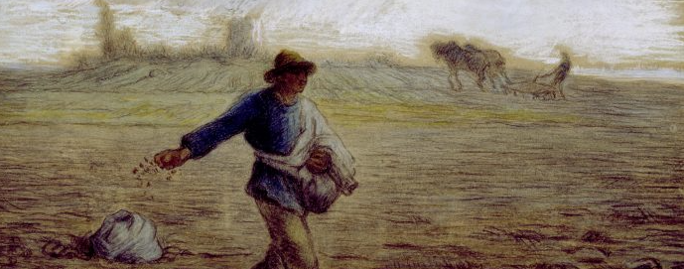

Focus: Jesus uses parables to teach life lessons.
As a factoid, there are 23 parables, 11 that are unique.
The parables in Matthew’s Gospel were particularly focused on convincing the Jews that Jesus was the Messiah. One way that he accomplished that goal was by centering his message around Jesus’ teachings and how they intersected with Jewish faith and tradition.

Jesus taught with stories, called parables. Like a fable, a parable also tells a simple story. Whereas fables tend to personify mythical creatures or animal characters – giving the same impression as an animated cartoon – Jesus’ parables use humans as its characters, and imparted a spiritual lesson.

Jesus was fulfilling a prophecy: In Matthew (Chapter 13:34-35) it says:
“….He spoke to them only in parables, to fulfill what had been said through the prophet: “I will open my mouth in parables, I will announce what has lain hidden from the foundation [of the world].”

Watch this video on YouTube: https://www.youtube.com/watch?v=XX-aAg4_U2Q
(copy & paste into new browser)

Jesus also knew his audience and met them where they were at. He spoke about things that they could associate with as well as things that were important to them: farm life, fishing, the sea, foods they ate, their suffering and the vulnerable and the importance of children.

Read the Parable of the Sower: MT 13:1-9.
Reflection questions:
- What kind of “soil” should we be like? And how can we do that?
- What are we supposed to do when we hear the Word of God?
- Thinking back on the video we saw, why do you think Jesus felt it necessary to provide the explanation to the disciples after he spoke to the people?

Read the Parable of Weeds Among the Wheat: Matthew 13: 24-30.
Reflection questions:
- Is the kingdom of heaven found on earth?
- What are the “weeds” in our society and in your own personal life?
- Who is the enemy?

The Explanation of the Parable of the Weeds Among the Wheat
Read passage Matthew 13: 36-43
Reflection questions:
- How does this explanation fit your own understanding of the parable?
- How can this parable be used to explain when evil happens?
- What does Jesus say will happen to the “wheat”?

